CHAPTER 2: Getting into genes
Worksheet 2.5

Dominant and recessive
Student: Class:

Red and yellow tomatoes
1. A student conducted a series of experiments with pure breeding red tomatoes and pure breeding yellow tomatoes.
The pollen from the yellow tomatoes was allowed to pollinate the stigmas of the red tomatoes. The seeds were collected and grown to determine the colour of the fruits of the first generation. All the first generation produced red fruit. The first generation plants were allowed to interbreed and the colour of the second generation fruit was determined. The results were:
red fruit = 360 yellow fruit = 119
(a) Explain why all the first generation produced red fruit.

(b) Calculate the ratio of red fruit to yellow fruit in the second generation. Round your answer to the nearest whole number.

(c) Explain why yellow fruit appeared in the second generation.

(d) Predict the proportion of tomatoes in the second generation that are likely to be pure breeding.

CHAPTER 2: Getting into genes
Worksheet 2.5

Ear lobes
2. The photos below show two types of ear lobes. Free ear lobe (F) is dominant to attached ear lobe (f).
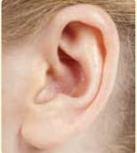 | (a) A homozygous woman with free ear lobes marries a man who has  attached ear lobes. Predict the types of lobes their children will inherit.
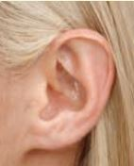  Photos: John Wiley & Sons Australia/Photo by Renee Byron | (b) Two parents who are hybrids for free ear lobes have four children.  Predict the proportion of free ear lobes to attached ear lobes in their children.

